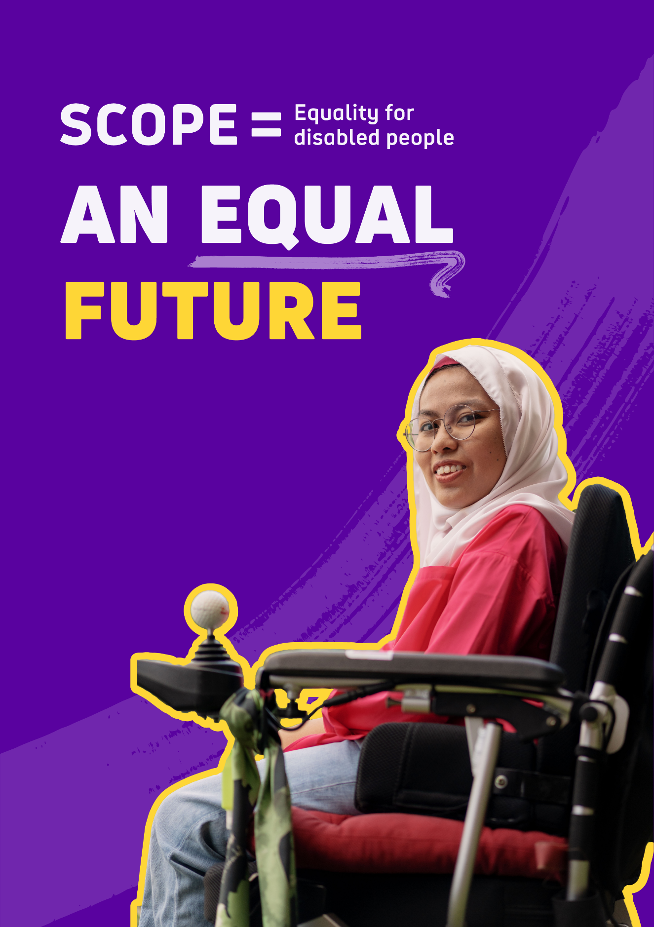

Our strategy from 2023 to 2033

Our vision
We won’t stop until we achieve a society where all disabled people enjoy equality and fairness.

Our mission
We are Scope.
We are determined to change the future.
Together, as a collective movement of disabled people, campaigners, donors, volunteers, communities, and businesses. We work every day to challenge attitudes and end disability inequality.

Setting out our vision for the future

Our goals
We were founded over 70 years ago to change society for disabled people and people with Cerebral Palsy. Despite progress in this time to legislation and rights, to inclusion and to expectations, millions of disabled people continue to experience inequality, negative attitudes, and prejudice every single day.
Scope exists to change this. We are a social change organisation focused on ending inequality. Now and in the future.
We’ve worked with over 450 disabled people, colleagues, volunteers, and our trustees, to create our vision of An Equal Future.
We know that equality is a right that cannot be taken for granted. We are relentless and impatient for this right to be afforded to every disabled person.
Too many disabled people are denied work opportunities, millions of disabled people experience a financial penalty simply because of who they are, and many of us have experienced negative attitudes because of our disability.
The recent impact of a global pandemic and cost of living crisis has only made these things worse, impacting disabled households far more than others.
Our strategy sets out the 3 areas we will focus our resource and make the biggest difference. We will be flexible on how we get there but we will be unwavering in achieving our vision.

A movement of change
Our strategy also describes how we will build and be part of a movement of:
- people
- volunteers
- campaigners
- partners
- funders
- civil society
- communities around the country
to achieve our vision of an equal future.

We aim in our first 3 years of this strategy to have over 300,000 campaigners and supporters join us.
We will work with:
- disabled people
- politicians
- businesses
- funders
- charities
- the public
to make our vision a reality and achieve transformational impact.

In communities across the country, our shops and services will be places for all those who want to work with us to create An Equal Future.

We will be making greater use of digital tools and technology to enable this vision. By doing so, we aim to provide advice and support to at least 3.5 million disabled people every year.

Equality, diversity and inclusion
Scope is an open place for every disabled person. For anyone who wants to change society. In the first 3 years we will do far more to reflect the diversity of our society, to listen to those experiencing discrimination on multiple fronts and build partnerships to amplify and end this discrimination. For too long disabled people have been ignored and overlooked. Scope exists to change this. To create An Equal Future.

Being disabled in the UK
16 million people in the UK are disabled. That’s 1 in 4 people or 24% of population.

Attitudes
- Our attitudes towards disabled people research has found 3 out of 4 disabled people (72 percent) experienced negative attitudes or behaviour in the last 5 years.
- 9 out of 10 disabled people (87%) who experienced negative attitudes said it had a negative effect on their daily lives.

The Disability Employment Gap
- We estimate there are a million disabled people out of work who want to work.
- The employment rate of disabled people is 54 percent. Compared to 83 percent of non-disabled people.
- The disability employment gap is 29 percent.

The Disability Price Tag
- On average, disabled households (with at least one disabled adult or child) need an additional £975 a month to have the same standard of living as non-disabled households.

Our strategy at a glance
We have ambitious plans for the next decade to achieve An Equal Future for all disabled people in the UK.

Our goals

Transform Attitudes
By 2026
- A significant change in media representation.
- An attitude change programme running in schools.
- A shift in attitudes in the workplace.
By 2033
- Disabled people no longer experience negative attitudes and discrimination.

End the disability price tag
By 2026
- A social energy tariff is in place for disabled households.
- A fairer, more dignified and supportive disability benefits system.
- Businesses are making goods and services more affordable.
By 2033
- Disability is no longer linked with poverty.

Close the Disability Employment Gap
By 2026
- A political commitment to close the employment gap.
- Continue to support disabled jobseekers into work.
- An Aspiring Leaders programme established.
By 2033
- All disabled people, who want to work move into, stay in, and progress in work.

What we do

- We influence society
We are part of a movement to end disability inequality nationally and in communities. We will unleash the power of our campaigners, donors, volunteers, shops and services to achieve change. We will amplify disabled voices to end inequality.

- We partner with others
By collaborating with Disabled People’s Organisations (DPOs), governments, employers and individuals we can work together to achieve An Equal Future.

- We provide support, information and advice
We empower disabled people and their families to have control over their own lives.

- We are led by insight and evidence
We will use this evidence to focus on what’s important to disabled people, improve our services and demonstrate what works to influence others.

Our strategic goals

Goal 1: Transforming attitudes

At Scope we have a proud history of challenging negative and outdated attitudes towards disabled people.
Our attitudes towards disabled people research has found that there consistently remains a stubborn lack of understanding of disability, and negative attitudes towards disabled people are still far too common. From outright discrimination to more nuanced and subtle exclusion, disabled people and families experience negative attitudes in many parts of their lives.

From the judgement of others about what disabled people are capable of, the constant questioning and having to justify yourself, to confrontation, discrimination and physical abuse. Disabled people still face huge barriers to full inclusion and equality in society.

For disabled women these experiences are more frequent. And for younger disabled people, these experiences are more common too. For disabled people who are black, or who identify as LGBT+, experiences of negative attitudes and behaviours are rooted in racism, homophobia and transphobia.

“When I went to the pub people looked at me. And started taking the mickey out of me, making me feel worthless and alone. I didn’t socialise for a while because of how it made me feel.”
- Scope research participant
These attitudes and reinforcing of stereotypes can come from lots of places and people. In our workplaces, on our streets, across social media and in the stories we consume through TV, film and other media. The impact of these negative attitudes and behaviour can be huge. For some, the experience of negative attitudes has led to leaving work, to stopping socialising and avoiding things they once liked to do. An Equal Future is possible.
“Once you say you're disabled, they think you must be a certain way, or you must look a certain way, speak a certain way, be able to do this and not be able to do that.
I think in the media sector, there needs to be a lot more recognition of disability, because we're actually 24 percent of the population. With discrimination, we're the highest but it's not really talked about, it's like people are too scared. Especially with hidden disabilities, because you wouldn't think straight away that I’m disabled.”
- Bryony Moss

By 2033 we want to see transformational improvements in attitudes towards disabled people and disability.
At Scope we will shine a light on all those working towards an Equal Future at our Disability Equality Awards. Showcasing best practice and champions who are tackling outdated attitudes.

By 2033 we want to see transformational improvements in attitudes towards disabled people and disability.
We believe society is stronger when everyone feels included, free from discrimination, negative attitudes, and behaviours of others. And where disabled people can enjoy equality and fairness. Achieving this requires institutions, individuals and disability organisations to think differently. Government, employers, the media, our benefits system and the general public all need to play a role.

Over the next 3 years we will:

Create a movement of media companies, production houses, creative agencies, media platforms, journalists and advertisers to shift the dial on disability.
We know the media industry has a huge role to play in shifting attitudes. From the stories told on screen and reported on. To the representation of disabled people in front of and behind the camera. We will work with companies, journalists and broadcasters to tell the disabled stories that matter and transform their approach to reporting and storytelling.

Launch a new programme to address attitudes early in schools. We know proximity and storytelling are integral to shifting attitudes.
We will work with schools across the country to create a generational shift in attitudes. And aim to reach 10,000 young people within our first 3 years.

Launch and run a campaign to shift attitudes in the workplace.
Our research has shown attitudes in the workplace are a priority for change amongst disabled people. We will work with employers to begin to shift attitudes in the workplace.

Shining a light on equality champions
We will shine a spotlight on all those working towards an Equal Future at our Disability Equality Awards. Showcasing best practice and champions who are tackling outdated attitudes.

How we will track our progress
We will track external progress on this goal by rerunning our research into attitudes. In 2022, 3 in 4 disabled people said they had experienced negative attitudes or behaviours in the past 5 years. By the end of this strategy, we aim to have significantly reduced this.

“Being a role model and raising awareness is important because it will allow the next generation to know it’s okay. Don’t be ashamed. You’re still a real-life superhero. You still can achieve.”
- Jorden ‘Akes’ James

Goal 2: Ending the Disability Price Tag

Being disabled in this country comes with a price tag.
The high cost of specialist products, the extra money disabled households need to spend on essential services to keep themselves warm and charge equipment, and the penalties associated with purchasing everyday goods like insurance or using transport. These all add up.
Our groundbreaking Disability Price Tag research identifies that disabled households need on average, an additional £975 per month just to have an equal standard of living.
On top of these extra costs, many disabled people are failed by our inadequate welfare system. Millions of disabled households are now living in poverty.
“The way that fuel bills have gone up and so many disabled people are stuck indoors, meaning that bills will obviously cost more for us. It’s hard, but we don’t have a choice. People don’t see this side of being disabled. We didn’t ask to be disabled, and disability doesn’t care how rich or poor or young or old you are.”
- Susan Donnelly
The pressure on disabled households to meet the extra cost of disability makes it harder to have a decent standard of living. It makes it harder to plan for the future, harder to participate in society and reinforces inequality. An Equal Future is possible.

“People don't see that disabled people pay more than anyone because they're providing double costs for their disability. As a disabled person, I feel like we don't matter. I just think everyone's walking around with their eyes shut. My spinal injury has brought about more costs. It’s more isolating because you’re worried about spending a pound over. And if you spend that pound over, you’re going to go without something else, whether it’s less on the electric, or some medical item that you need. You have to go without to buy that item, and it does mean getting into debt. It has to happen.”
- Samantha Foster
By 2033 we want disabled people, households and families to have an equal standard of living and to have ended the financial inequality associated with disability.
We can end the Disability Price Tag by working together with
- disabled people
- businesses
- Governments
- politicians
- market regulators
We can create an equal society, where everyone can participate and where disability is no longer synonymous with poverty.
Through our information, support and advice we will make sure disabled households are equipped to navigate the welfare system and reduce extra costs.

Over the next 3 years we will:
Campaign to secure the introduction of a social energy tariff.
To make sure disabled people are not unfairly penalised by the energy market. We intend to achieve this by 2025.

Work with disabled people to propose a fairer, more dignified and supportive approach to disability benefits.
Making sure the welfare system provides an adequate level of benefit. We intend to achieve this by 2026.

Work with businesses to better understand their disabled customers.
Making sure that specialist goods and services are accessible and affordable.

How we will track our progress
We will track external progress on this goal by regularly publishing the Disability Price Tag figure. In 2023, the Price Tag was £975 per month. By the end of this strategy we aim to have ended the unfair Disability Price Tag.

Goal 3: Closing the Disability Employment Gap

A fulfilling and satisfying career, for those who want it and are able, can be hugely rewarding.
The Disability Employment Gap is the difference in the rates of employment between disabled and non-disabled people. And it has barely changed in the last decade.
Too many disabled people are written off from entering the workplace at a young age, experience discrimination from managers and employers, and have low expectations placed on them simply because they are disabled.
Being talked over, being turned down for a promotion, being spoken about but never to and being told to “get on with it” are just some of the common things disabled people still experience in the workplace.
Adjustments, flexibility, support and understanding are often missing.
“I've had responses along the lines of, 'Please give us a lot of detail about your disability and then we can figure out something that means it's fair for everyone.' Which gave me the impression that they thought I was asking for special treatment rather than just asking for support in making things less of an absolute struggle”
- Sarah Ollier
It is no surprise disabled people are twice as likely to leave their jobs as non-disabled people.
A huge amount of disabled talent is going to waste. An equal future is possible.

“I've had responses along the lines of, 'Please give us a lot of detail about your disability and then we can figure out something that means it's fair for everyone.' Which gave me the impression that they thought I was asking for special treatment rather than just asking for support in making things less of an absolute struggle.”
- Sarah Ollier

By 2033 we want to see every disabled person who wants a job to have got one and the employment gap to have closed.
Closing the Disability Employment Gap requires action from employers, from Government, from charities and from employment support providers so that disabled people can not only find work but stay there and reach their full potential. And this thinking is critical as ways of working, the types of work and the role of technology and automation can bring huge benefits as well as potential challenges.
Closing the Disability Employment Gap will bring huge benefits not just to individuals but to companies and society.
Halving the disability employment gap would bring huge returns to this country. If we were to do so, we would experience a £17 billion increase to the economy each year.
Increasing the numbers of disabled people in employment also benefits business by enabling them to expand markets, grow customers bases and increase profits.

Over the next 3 years we will:

Secure political commitments to close the Disability Employment Gap.
Closing the Gap requires Government leadership and action we will campaign to build political consensus on the action required of Government. We intend to do this by 2025.

Directly support disabled job seekers into work through our voluntary and tailored employment support
Our best-in-class services and colleagues have supported thousands of disabled people. We intend to continue this and use the evidence from our interventions to demonstrate there is a better, personalised and wholly voluntary way to support moving disabled people closer to work.

Work with aspiring disabled leaders through a new co-produced leadership programme.
To address the lack of senior disabled leaders and role models we will build a community of disabled leaders committed to creating An Equal Future.

We will work with employers at every stage of their journey, partnering with those who want to make UK workplaces better.

How we will track our progress
We will track external progress on this goal by measuring the Disability Employment Gap. In 2023, this gap was at 30 percentage points. By the end of this strategy, we hope to have closed it.

An equal future for all disabled people

Putting equality, diversity and inclusion at the heart of everything we do.
At Scope, we want a society where all disabled people enjoy equality and fairness. This means absolutely everyone.
To achieve this, we are transforming the way we work so that equality, diversity and inclusion are at the heart of everything we do.
We have a long and proud history of championing disability equality. But we want a more inclusive future. From our helpline to our high street stores, our boardroom to our online community we will make everyone feel included.

As part of An Equal Future we will:
- Increase understanding of our customers and supporters so we can better meet their needs.
- Partner with grassroots and other organisations to address the multiple marginalisation many disabled people experience.
- Commission large-scale research exploring intersectionality within the disabled community so that we can challenge power imbalances and push for change for our whole community.

“I feel like being a black man with a disability, sometimes you feel like you haven't got a voice. Life's already hard being black, growing up trying to make something of yourself. It's always harder. Then bolting a condition on to it, which affects you mentally, physically, emotionally - you're having to work double-time so people look past the condition.”
- Jorden ‘Akes’ James

A future that leaves no one behind
No organisation or strategy can predict with any certainty what will happen in the future across the world. Yet there are some things that are happening now that cannot be ignored.

Automation and artificial intelligence
The use Automation and Artificial Intelligence has grown exponentially in the past few years and will continue to do so over the next decade.
We will work with disabled people to understand the future of work, the role of AI in the workplace and the opportunities and challenges AI could present to disability inclusion.

Climate emergency
No one can ignore the emergency our planet faces now and in the future due to climate change. We will not ignore our role as an employer and as a campaigning organisation in responding to this emergency.
Disabled people all across the world are disproportionately impacted by both the impact of climate change and the policy response to dealing with it.
As an employer we will continue to minimise the environmental impact we have on the world. We will continue to tackle our own direct and indirect emissions.
As a campaigning organisation we will make sure disabled peoples’ voices are heard on climate change and responses are inclusive and accessible.

A future that is accessible
Inside and out we aim to be accessible. Over the next decade we will continue to promote the benefits of accessibility to everyone.
As part of An Equal Future we will:
- Hold ourselves to the highest accessibility standards so that our documents, our ways of working, our advice and our communication is accessible.
- Lead the way on accessibility as default, and influence others to do the same.
- Push the boundaries in the creative and customer industries on accessible and inclusive design to demonstrate what is possible.

A movement of change
At our heart we are a social change organisation. We are impatient for progress. And impatient for action.
We campaign on the issues that matter most to disabled people and disabled families.
We want to provide a platform to disabled people and amplify their voices, as well as mobilise wider society in support of justice and equality.
We know we cannot achieve our vision and goals alone. We are part of a larger, more diverse movement that is seeking to end injustice for the 16 million disabled people in the UK.
We will add value to this movement and help achieve An Equal Future by making sure everyone has a role, and by focussing on changing the hearts and minds of those who need convincing.
Ending inequality for disabled people requires thousands of people, volunteers, businesses and communities to come together and campaign for change.
Over the next 3 years we will grow our community and movement of supporters to over 300,000 to make this happen.
Through our shops, our community hubs, our networks and relationships we will build a powerhouse of activism where disabled and non-disabled people will come together to end disability inequality.
We will seek to work far more closely with Disabled People’s Organisations, in our communities to push for change locally and nationally.

We will grow our membership to 15,000 by 2033 and will make sure our members reflect the diversity of the disability community.
We will make sure that every person or organisation who interacts with us, whether donating to our shop, volunteering with us or using support services plays a vital part in our vision for a fair society.
We know we can only end disability inequality by working together. So, we’ll seek to develop partnerships and relationships that can achieve transformational and sustainable change.

“When charities, DPOs, companies, and campaigners team up, it packs a punch. They make a bigger impact, bring diverse expertise, boost awareness, and have more say in policies. Companies also add innovation, and together, they attract more funds and resources. This approach ensures that disabled voices are heard and keeps everyone accountable for pushing equality forward.”
- Dr Shani Dhanda

Supporting more disabled people and their families
Our services are there for any disabled person, family or household that needs us.
During our last strategy, our services reached 3.5 million people annually.
Almost 7 million people accessed our online information and advice and 8.7 million have accessed our online community. Yet our helpline is only able to answer 2 in 3 calls.
Over the course of this strategy, we will seek to increase the amount of people and families we can support. So that anyone who needs our advice can access it. We will use the insight we get from our services to influence others.
We will increasingly look to increase our online and digital support offer, so that people can access information in a way and at a time that suits them. And we’ll be looking to make more of our shops as places for disabled communities to come together.
Through our employment services we will continue to demonstrate that a voluntary and tailored support offer is what this country needs to tackle the employment gap.
We will strengthen our commitment to coproduction. Putting disabled people and their families at the heart of our work.
“Since talking to Scope, I've been saying, 'It's not okay.' And I've never done that before. I think it's because Scope's told me that if I'm not happy with something, I should say something, not just accept it.”
- Samantha Foster

Supporting those living with cerebral palsy
We are proud to support those living with cerebral palsy. It is clear this is best achieved through the 3 goals we have set out in this strategy.
We will continue to work with the cerebral palsy community, particularly where needs are not currently being met. We will seek opportunities to do this through co-production and partnerships.

Working in partnership
We are immensely grateful to every funder, trust, donor and company who works with us to end disability inequality.
We know we can only achieve An Equal Future by working with others.
With businesses who want to work alongside us in tackling the disability employment gap.
With companies who recognise their role and influence in changing attitudes.
With organisations who understand the value of accessibility and opportunity of supporting us to the end the extra costs disabled people face.
And with funders, trusts and donors who can support us to deliver interventions that get us closer to ending disability inequality.

Creating an impact
Everything we do is underpinned by robust evidence and insight with a sole focus on ending disability inequality.
Every interaction we have with anyone will be to create an equal future for disabled people.
We want our impact to be transformational not transactional. And to be sustainable, not in the moment.
We will publish our progress towards An Equal Future annually.
As part of our strategy, we will:
Be Open
By tracking and publishing our progress annually through our impact reports.
Be Connected
By building our evidence base of what life is like for disabled people through research and analysis and sharing our work with anyone who wants to use it.
Be Pioneering
By growing the size and influence of our unique research panel, working with partners who want to understand disabled people.
Be Courageous
By publishing evaluations of our services and our interventions, sharing where our interventions haven’t worked so others can learn.
Be Fair
By co-producing our work with disabled people and putting our commitments to equality, diversity and inclusion at the centre of our programmes of work.

How we developed this strategy
This strategy has been created with the following people and activities:
- A Strategy Steering Group made up of disabled customers, volunteers and colleagues.
- Engagement with over 450 disabled people, colleagues and volunteers.
- Reviewing 30 pieces of existing Scope research.
- Surveys of colleagues and disabled people to understand priorities for change.
- Analysis of external datasets.

“When I think of ‘An Equal Future’ I imagine a society where every person, regardless of their background, identity, or abilities, enjoys equal opportunities, rights, and access to resources. I envision disabled individuals living without fear of being subjected to inhumane and derogatory treatment by the media.
In 10 years, I hope the UK will be a place where the principles of independent living are achievable for all, with a special focus on ensuring that disabled people can fully embrace them.”
- Dr Shani Dhanda

Join us in creating An Equal Future
Our purpose is to end disability inequality. We cannot end it alone. An Equal Future will only be achieved if all of us join together.

Become a member
Donate to Scope
Volunteer
Find a fundraising event
Do your own fundraising
Campaign with us

Scope Attitudes research (2022)
Scope Attitudes research 2022
Scope Disability Price Tag research (2023)

