Do The

Right Thing

Supporting disabled

people through the

cost of living crisis

November 2022

Contents

4 Foreword
6 Executive Summary
12 Context
15 How the crisis is affecting disabled people
25 Disabled people’s experiences with energy and water companies
29 The impact of government support
31 Recommendations for government
39 Recommendations for Ofgem and Ofwat
43 Recommendations for energy and water suppliers

Foreword

My name is Anne Vivian-Smith. I used to be fit and well, able to work full time. My husband and I were never rich, but there was enough money for good food, the odd treat and some great gigs. Whenever there was a big bill, we’ve taken second jobs and paid our way.

Then I got ill with a neurodegenerative autoimmune disorder. Within two years I was in a wheelchair unable to work. We now live on my husband’s salary and my disability benefits. We didn’t have as much money, but we could still get by.

I checked our British Gas account in January 2022. With no warning, our monthly payments had risen from £84.22 to £145.19. And it got worse. After two more increases, our monthly payment is now £258.72. It’s going up again in January 2023.

I have immunosuppressant medication, so I’m a high risk for infection. I’m being forced to take a huge risk; our heating isn’t dropped by a degree, it’s off.

There is no money.
Life costs more if you’re disabled.

I have to buy special cutlery and cooking equipment. I have more laundry and replace my clothes more often than non-disabled people. I use hoists to move between my powered wheelchair, bed and shower chair. I have an electric shower, bed, door opener and loo. All these things remain on charge. What would you turn off?

I have clawed money from everywhere. I’ve found it’s hard to get a wheelchair to the front of the reduced food section in a supermarket. My husband and I are tired, tense and frightened.

Navigating benefits, grants, registers and tariffs is a nightmare. The information almost feels like it was made deliberately as inaccessible and obscure as possible.

We have had some help through Scope’s Disability Energy Support. The advisor, Antony, was so patient and reassuring. He presented information in a way I could understand and helped me identify some things I could do. This helped take some of the pressure from me.

It’s still worse than awful, but we have made some small changes. We now have a Smart Meter. It is both my enemy and my friend. It highlights some of the most expensive energy use in the house but turns every action into a transaction. A shower for me costs over £5.

It’s hard that my life which used to be so full has become this small. It’s like being collateral damage, totally helpless, dreading what will happen next.

I really need people to hear this so I hope government, regulators, suppliers and others are reading this Scope report. The cost of living crisis is having a devastating impact on disabled people’s lives. Those in power must take action now.

Anne Vivian-Smith
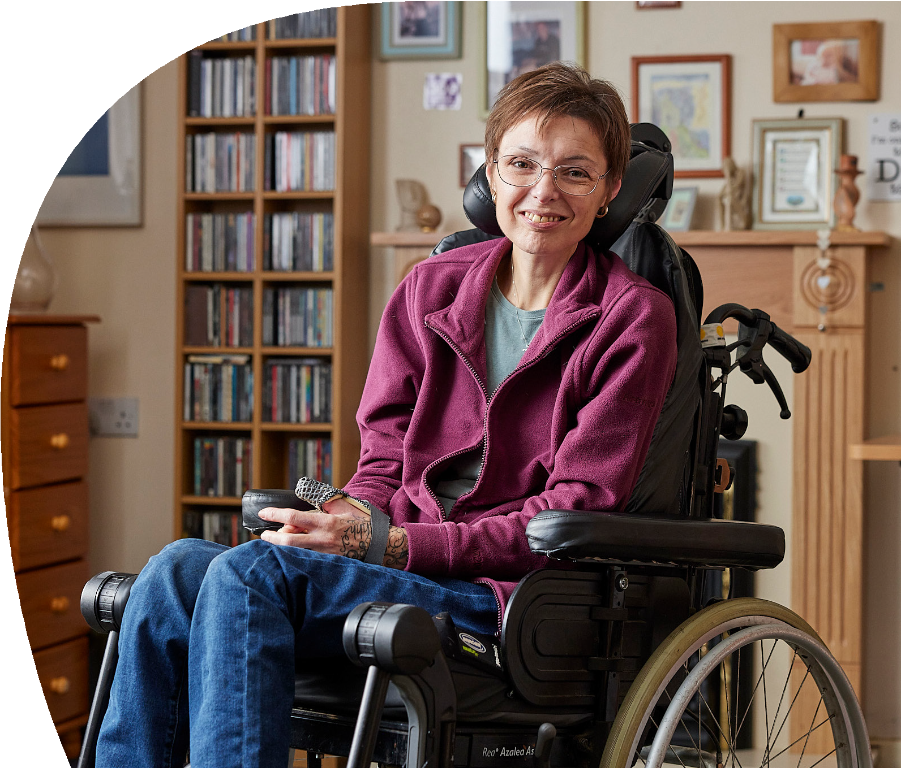

Executive Summary

We are in the middle of the worst cost of living crisis for decades, one that disabled people did not cause, but are being hit hardest by. Disabled people feel let down and forgotten by the government and are struggling with the price of essentials such as energy or food, often having to make devastating decisions about what to prioritise.

At Scope, we know that life costs more if you’re disabled. Even before this current crisis, disabled people already faced extra costs of £583 per month on average. For almost a quarter (24%) of families with disabled children, extra costs amount to over £1,000 a month.

High energy bills are making the situation far worse - even with government schemes in place. Over a third of disabled adults feel that their impairment or condition has an impact on how much energy they use and 9 in 10 (91%) are worried about energy bills this winter.

There are also many disabled people who are not in work and welfare payments are their only income. Benefit rates have seen a significant real-terms cut due to not keeping pace with rising costs - up to £678 in real terms for someone receiving income based Employment and Support Allowance as of October 2022.

Prior to the cost of living crisis, more than 4 in 10 families who rely on disability benefits were living in poverty. We are incredibly concerned that huge numbers of disabled people will be pushed into further destitution this winter. Over half (51%) of disabled people are concerned about affording food over the next few months.

Disabled families need help and support through this crisis. Scope’s dedicated Disability Energy Support service has seen an almost 500% increase in the number of referrals, compared with this period last year. And in September 2022 alone 44,000 people accessed Scope’s cost of living advice and support, a 72% increase compared to this time last year.

The government has said that it wants to target support to those who need it most, yet the support offered so far hasn’t touched the sides for many disabled people and their families. Nearly 3 in 5 (57%) disabled people eligible for the £650 cost of living payment said it would not be enough to cover their increases in energy and essentials. And 4 in 5 (80%) disabled people who received the £150 cost of living payment said it would not be enough to cover their increases in energy and essentials. The government has promised further help and cost of living payments for disabled people, but this will not be until April 2023 at the earliest. Disabled people cannot wait that long, more help is needed now.

This report is based on evidence we have collected from our energy and benefit support services, focus groups with disabled people and families, polling, and analysis of government datasets. It paints a devastating picture of how disabled people and families are facing the brunt of the cost of living crisis. Change requires government, regulators and businesses to work together to tackle this crisis, and collectively do the right thing.

The government must:

- Urgently establish an Energy Social Tariff for disabled customers – a discounted rate for disabled people who need to use more energy, to target support to people who need it most.
- Bring forward the second £150 Disability Cost of Living Payment – disabled people cannot wait until next spring.
- Reverse eligibility changes to the Warm Home Discount that excluded disabled people – nearly 300,000 disabled people are now missing out on vital support with energy bills because of these changes.
- Overhaul the process for uprating benefits – the process has caused much stress and left disabled people hundreds of pounds worse off.
- Bring forward, to this winter, some of the second Cost of Living Payment for those on means-tested benefits – disabled people are already struggling to pay their bills.
- Raise awareness of the Household Support Fund (HSF) and improve the application process – more funding for the HSF has been announced, yet many disabled people are unaware of its existence, and few have been helped by it.
- Review standing charges on energy bills – disabled customers are often unaware these charges are being added to bills, and do not reflect energy used.
- Provide an energy assistance payment for families with seriously ill children who are unable to access medical grants from the NHS – NHS reimbursements, or medical grants, for additional energy costs of running medical equipment at home are inconsistent or non-existent.

The regulators Ofgem and Ofwat must:

- Establish a moratorium on the installation of prepayment meters (PPMs) for disabled households – the risk of serious harm for disabled households by going off supply means no PPMs should be installed.
- Remove higher costs for people on prepayment meters – often disabled customers on PPMs have the lowest incomes and can be paying off a debt. It is unfair they are then further penalised by paying higher costs.
- Enforce rules more quickly and consistently – it is more vital than ever that the regulators ensure that companies do not fail disabled people.
- Share financial and affordability data from disabled households, with the consent of the customer – identifying disabled households who are struggling with bills as early as possible can prevent debt building up and support being offered.

Energy and water companies must:

- Prioritise disabled customers who are already in debt – a worrying number of disabled households are already in debt to their energy or water supplier, often both, even ahead of the winter when costs will rise.
- Provide effective, empathetic support for disabled customers – all too often interactions with suppliers for disabled people are stressful, negative experiences.
- Increase awareness of ‘Water Sure’ – the scheme can provide vital support for disabled households, but awareness is low.
- Increase awareness of the Priority Services Register (PSR) – the protection and support disabled households gain from the PSR is vital, but too few are registered.
- Establish two-way signposting with a dedicated number for charities – good relationships between charities and companies can often improve outcomes for disabled people seeking support.

For more information on the findings and recommendations of this report, contact:
Tom Marsland, Policy Manager
tom.marsland@scope.org.uk

Context

There are many reasons why a disabled person’s condition would lead to higher energy usage. Vital equipment such as mobility scooters, ventilators, adapted cars and hoists need power. Washing machines and showers are used more frequently when conditions lead to needing to change clothes frequently. There are often higher heating bills because some conditions make it harder to regulate body temperature. Turning the power off is not an option and cutting back can have serious consequences for disabled people’s health and wellbeing.

Disabled people also face extra costs in many other areas. For example, paying for food and other items to be delivered when going out to buy them is difficult or impossible. Or paying more for insurance or requiring more expensive food due to specific dietary needs. Disabled people tell us that their costs are spiralling, and they no longer know where to turn.

As of October 2022, a single disabled adult over the age of 25 on income-based Employment and Support Allowance (ESA) and associated premiums has already seen a cut of up to £687 in real terms.

We asked parent carers what three words they would use to describe the impact of the cost of living crisis on their families.

Answers included:

- Scary, stressful, worrisome
- Unfair, challenging, restrictive
- Trapped, stuck, punished
- Destabilising, scary,hopeless
- Depressed, isolated,poverty
- Restricted, powerless,anxious
- Anxiety. Difficult choices
- Nightmare, anxious,budgeting
- Eat or heat
- Terrifying, humiliating,distressing

This report sets out what disabled people and parent carers of disabled children have told us this year. It paints a stark picture. The report also provides clear recommendations for government, regulators and utility companies, setting out what they can do to target support to disabled households as a matter of urgency.

Unless otherwise mentioned, all statistics and percentages are taken from the following pieces of polling:

Survey of 1050 nationally representative disabled adults in the UK, 26 August to 2 September, carried out by Opinium on behalf of Scope.

Panel survey of 69 participants of parent carers of disabled children aged 0 to 25, 8 to 12 September 2022, carried out by Scope’s Research Panel.

Survey of 1,000 disabled adults in England and Wales, 15 to 21 September 2022, carried out by Opinium on behalf of Scope.

Survey of 1,000 UK adults responsible for energy bills and with a disabled person in the household, 22 to 23 September 2022, carried out by Opinium on behalf of Scope.

Scope’s Disability Energy Support Service

In November 2020, we launched the Disability Energy Support service, offering dedicated support and tailored advice to disabled people and their families on managing and reducing energy and water bills.

Through our service, we provide advice on issues such as dealing with utility debt, implementing efficiencies in the home, gas safety and registering to the Priority Services Register (PSR). We provide advice on the benefits system and partner with organisations who provide insulation, boilers and white goods replacements.

In the last 12 months, we are proud to have supported 3,514 customers with tailored advice, helping them save an estimated total of £1.5 million through the support and advice provided. In addition to this, we have educated those customers on the importance of gas safety and the
benefits of the Priority Services Register.
13
9

How the crisis is affecting disabled people

Household finances and debt

Disabled people’s finances have reached crisis point. For some it is no longer a case of choosing between “heating and eating” – many disabled people can’t do either.

Right now, 57% of disabled people say their income doesn’t, or only just, covers their bills. And half of disabled people say they will struggle financially this winter, unable to afford all essentials.

Callers to our Disability Energy Support service and helpline are feeling isolated and anxious. More than 4 in 10 (43%) callers are already in energy debt, on average £1,351.

And families who use Scope’s services have told us they are unable to cover bills and essentials including food. Some parent carers are using credit cards and overdrafts to cover these costs, but cannot afford repayments and charges, which also leads to increases in debt.

“I am about to lose £700 a month from my universal credit claim, due to my disabled young adult (aged 19) staying on in education and they are no longer eligible for the child/disabled child payments. I am a carer on a fixed income. I cannot make any extra money. I need to use the washing machine, to turn on the lights, to use the cooker, I need to buy certain foods because my autistic daughter only likes certain brands. I have and care for my two disabled young adults in my household… my outgoings mean that after August I will be left with £7 a month to live on. How can anyone be expected to live like this? It’s tragic, humiliating, and I have never felt so let down by a government in my life.”
Member of Scope’s Online Community

39% of parent carers we surveyed in September 2022 said that they or their partner have considered increasing, or have increased, their work hours, to generate more income for their families. But they face a number of barriers, including
- Being a single parent and the primary carer for their disabled child
- Not having a support system to help with childcare whilst they work
- Lack of accessible childcare which meets their child’s needs
- Costs of childcare for working hours outside of school hours.

Since the start of 2022

36% of parents and carers we spoke to have pawned or sold possessions.

32% have borrowed money from family or friends for essential purchases, and a quarter have accessed support from a food bank.

“The increase in the bills has put us beyond help really, we are in survival mode being squeezed for every penny we can just about manage.”
Polling participant

Benefits and financial support

The majority of working-age households that include a disabled person will be in receipt of some form of benefit. From support for the extra costs disabled people face, to help for those who are unable to work because of their condition, or for people on low incomes – the benefits system should provide a safety net.

But most disabled people who receive benefits have seen a sizable cut in their real-terms income over the last year, as benefit levels have failed to keep pace with rising prices. Scope calculates that from April 2022 to April 2023, a single disabled adult over the age of 25 faces real terms cut of up to £352 for those on contribution based Employment and Support Allowance (ESA) and £840 for those on income-based ESA, because of the rapid rise in inflation.

These real term cuts affect close to 7 million disabled people in England and Wales. For those who rely on more than one benefit, the impact of these cuts will be greater - and families with disabled children stand to lose the most.

In November 2022 the Chancellor announced that benefits will be uprated in line with inflation in April 2023 - an announcement that Scope welcomes. However, benefits will not regain the value they had in 2021 until 2024. This is due to the way that benefits are uprated – annually and using a measure of inflation from September, which lags 6 months behind the actual time benefits are uprated in April. It is clear this uprating system does not work in times of rapidly rising inflation. A reconfiguration of this system, and additional financial support for disabled people this winter, is therefore essential.

The impact of these real term cuts has been devastating. In September 2022, over half (58%) of callers to our energy helpline had benefits as their sole means of income, and on average had energy debts of £1,417.20.

Support with benefits is one of the main reasons people give for calling Scope’s helpline, and we regularly hear from families in dire situations. Parent carers often ask for help with identifying what benefits they’re eligible for, help with how to fill in Personal Independence Payment (PIP) and Disability Living Allowance (DLA) assessment forms and support with appeal processes. Scope’s webpages on benefits and funding the extra costs of being disabled has seen an 861% increase in views compared to this time last year. For funding the costs of having a disabled child this is even more stark – with a 1,367% increase in unique page views in comparison to this time last year.

Parent carers of disabled children tell us that long waits for benefits assessments and decisions put further stresses on their finances. Since 2015 there has been a steady increase in waiting times from when someone starts their PIP claim to receiving a decision, rising from just over 5 weeks end to end on average, to 18 weeks as of July 2022.
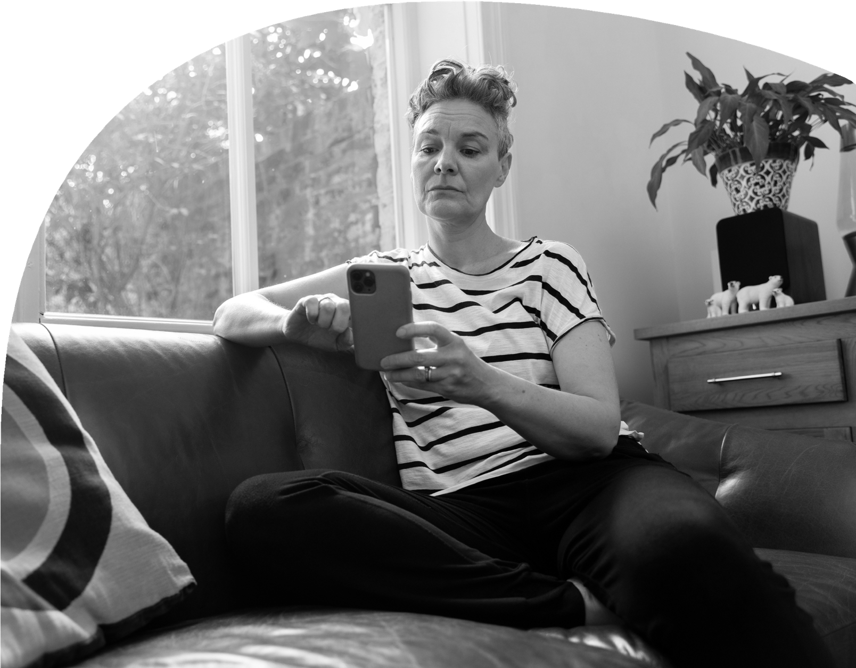

Impact on physical health and conditions

The cost of living crisis is having a severe effect on the health of disabled people, with people forced to make choices that are detrimental to their health.

71% Of disabled people who need to use more energy for heating because of their longterm condition or impairment are concerned that they will not be able to heat their home this winter.

40% Said that going without heating would cause them to be uncomfortable or in pain.

31% Said it would severely affect their health.

9% Said that going without heating could put their life at risk.

The situation is similar for families, with nearly a third (32%) of parent carers saying the cost of living crisis is affecting the physical health of their child. Activities which can be beneficial to their child’s health, for example swimming, are being cut down on.

“There’s not a lot we can do! What we used to do, even before the rise in bills, was to wear more clothing and only switch on the heating when absolutely necessary. Now, my aged and ill mother-in-law has moved in with us. Our energy usage has risen (and will obviously rise even more in the winter) just as the prices started to sky-rocket!”
Polling participant

Emotional wellbeing and mental health

The crisis is unsurprisingly having a serious effect on the emotional wellbeing and mental health of disabled people and their families.

Stress and worry about affording meals, travel, energy bills and other essentials are taking their toll.

Over half (52%) of disabled people say that increasing costs are negatively affecting their mental health, with a similar number (46%) saying it was also negatively affecting the mental health of their family. 1 in 4 (26%) of disabled people also say that increases to costs are causing arguments in their household.

The situation is even worse for parent carers, with 88% saying that the cost of living crisis has had an impact on their family’s emotional wellbeing.

“[The cost of living crisis] really affected mine and my daughter’s mental health. She’s old enough to understand we can’t afford basics with price increases. She worries about me and bills when she should be focusing on her education and having fun with friends.”
Member of Scope’s Online Community.

We’ve also seen safeguarding concerns regarding mental health increase across Scope’s services due to the cost of living crisis, with cases more than tripling in 2022 compared to 2021.

Choices and sacrifices

Many disabled people are making heart-breaking choices and sacrifices to get by. Scope’s helpline has heard from disabled people who are only heating one room in their house, or none at all, only watching TV for an hour or day, or only eating one meal a day.

Rising costs are also having an impact on disabled people’s mobility and independence. We regularly hear from people who can no longer afford to run a car, employ a personal assistant, or charge mobility equipment such as electric wheelchairs and hoists

“My daughter has autism and ADHD, it is hard to explain to her why we can’t have things, why we can’t go places, why she can’t go to a birthday party because I can’t afford the gift. I am also autistic ADHD with no family support and the added stress is killing me.”
Parent of a disabled child
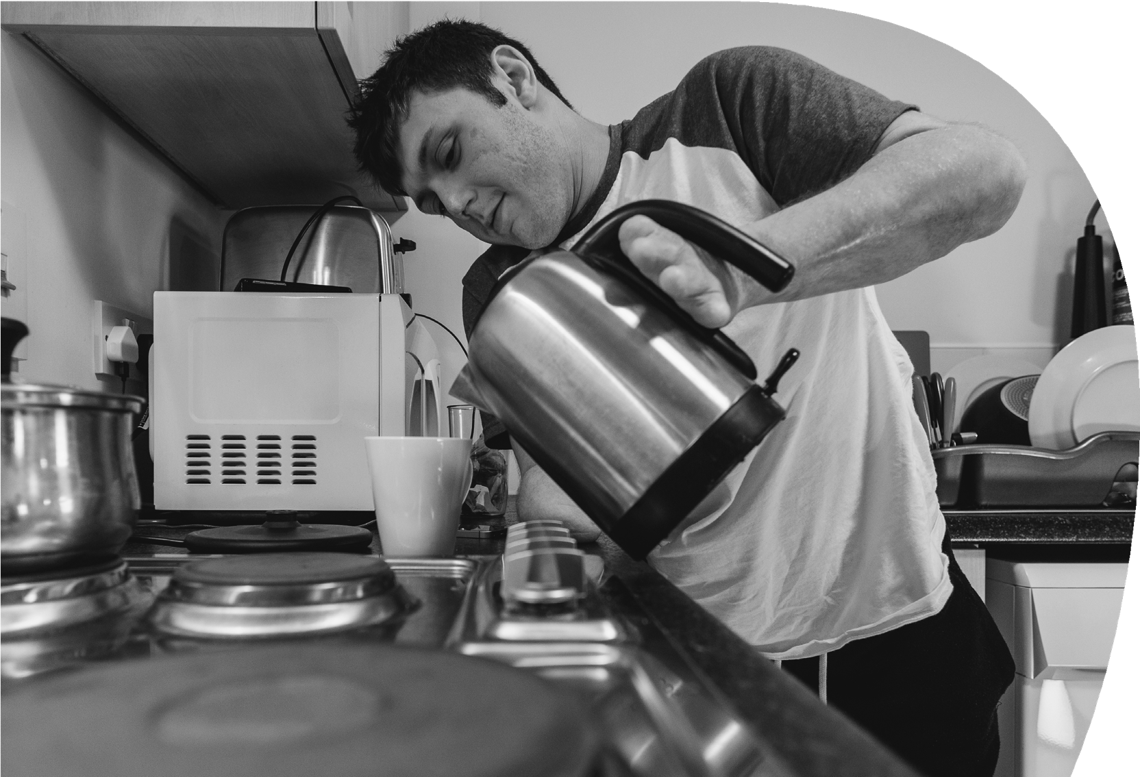
As food becomes more expensive, disabled people are forced to take more and more extreme measures. Two-thirds of disabled people who are in receipt of benefits are worried about affording food over the next few months.

Of these, nearly half 48% plan on skipping meals and worryingly over a fifth 22% say they will not be able to afford
a particular food they need due to their condition, such as pre-chopped vegetables or gluten-free food.

Disabled children are also missing out on leisure activities and childhood experiences as parents try to reduce spending. Over two-thirds (65%) of parent carers have cut back or stopped family day trips or activities, and just over half (51%) have cut back or stopped buying computer equipment, toys, gifts or birthday and Christmas presents.

“My autistic son relies on his computer to interact with friends and family around the world. We have had to restrict the time his computer is on during the day, causing meltdowns and frustration.”
Member of Scope’s online community

Scope website page views comparisons, September 2021 compared with September 2022

Help with Gas and Electricity
1,573 page views in 2021
11, 514 in 2022

Funding the extra costs of disability
979 page views in 2021
4,963 page views in 2022

Benefits and mental health
213 page views in 2021
7,521 page views in 2022

Disabled people’s experiences with energy and water companies

Rising utility bills, especially rising energy bills, are the biggest driver of the cost of living crisis. It is more important than ever that utility companies prioritise their disabled customers and ensure that extra support is offered this winter and beyond. When utility companies get it right, it is of immense benefit to both customer and company, but all too often this isn’t the case.

Quality of supplier support

Energy and water companies have a duty of care to their customers, and licence conditions that require companies to offer support - particularly to their ‘customers in vulnerable circumstances’. Support from energy and water companies is vital for disabled customers and must be available when needed.

However, we know this is not always happening. Energy debt is one of the topics that disabled people need most assistance with when they contact Scope’s energy helpline. This strongly suggests that energy suppliers are not providing the help and support required.

Far too often an energy supplier’s response is to simply attempt to install a prepayment meter (PPM) to recover the debt. More than 2 in 5 (45%) of households with a disabled person have experienced some issue with their energy supplier in the past 12 months. A fifth (18%) have been overcharged, reporting that their direct debit payments were too high. 1 in 8 received poor customer service (12%), while 8% have been subjected to incorrect bills or billing mistakes, with the same proportion (8%) saying their supplier has gone out of business.

“I have emailed and messaged my energy supplier via social media, but they have never replied to my pleading for help with rising costs.”

“It is difficult to get through to my supplier for the correct support.”

“My supplier was unable to offer any practical or financial help to me. Just advice on how to reduce utility costs overall - which I was doing anyway - rather than reducing charging rates.”

Polling participants

Prepayment meters and self-disconnection

Callers to Scope’s Disability Energy Support service regularly tell us about poor supplier practice. Often this is in relation to the forced installations of PPMs. These are often used by energy suppliers to recover a debt when customers cannot pay. Ofgem regulations make clear that PPMs should only be installed where it is appropriate to do so, namely where a disabled customer would not be at immediate risk if they went off supply, is able to easily top up, and can afford to do so.

Almost three quarters of those on a PPM (72%) have experienced problems in the last 12 months. This includes being forced to ration their energy usage in order to not go off supply (50%) and going off supply either to save money (26%) or because they were not physically able to top-up due to their impairment (14%). Of those who have self-rationed or been cut-off, nearly half (47%) mention they have had to cut down on essentials such as using their fridge, cooker or phone, and a quarter (25%) say their or someone else in their household’s health has been put at risk.

Worryingly, over a quarter (28%) of those who experienced an issue with their pre-payment meter said their supplier didn’t offer them any support.

“I have been going off supply due to being too scared to use heating because it’s so very expensive. I’ve been using a duvet and dressing in layers of clothing instead.” Polling participant

It is hard to argue that forcefully installing PPMs in households where there is a disabled person or child is appropriate – yet this is exactly what is happening.

Sadly, Scope’s helpline has seen far too many examples of this. One caller needed to keep medication in the fridge and going off supply would render that medication unfit for use. Yet their supplier still tried to forcefully install a PPM to recover debt.

The risk is that customers self-disconnect if they cannot pay for top ups, with serious consequences to their health and wellbeing.

The Priority Services Register

The Priority Services Register (PSR) is a vital tool for supporting disabled customers and households. Signing up to the PSR gives a customer extra help from their energy or water company and it is free to sign up, without needing to show proof of condition, age or situation.

A household is eligible for the PSR if someone in it has either reached state pension age, is disabled or has a long-term medical condition, is recovering from an injury, has a hearing or sight condition, has a mental health condition, is pregnant or has children under 5, or has extra communication needs.

Being on the PSR gives a household access to information in an accessible format, notice of planned power cuts or water supply issues, identification schemes where company staff give a password to prove it’s a genuine call, nominee schemes where bills to a family member or carer of choice, priority support in an emergency, and help with meter readings.

Two thirds (66%) of disabled people registered on the PSR would recommend the scheme to others that need support. The biggest issue, however, is making sure all eligible disabled customers and households are on the PSR in the first place. Our evidence suggests that just under half of disabled people (48%) have heard of the PSR. Among those that are familiar with the register, only 67% are registered with one or more of their electricity supplier, water supplier, electric and gas network, and gas supplier.

The impact of government support

The evidence we have set out above clearly demonstrates the extent of the crisis. Disabled people are among the hardest hit and government’s response must recognise that. The government has introduced a range of measures since February 2022 including targeted help for those on benefits and a £150 one-off payment for disabled people, both in 2022 and scheduled for 2023. On top of this, the government has intervened to set the energy price cap. Whilst these are all laudable and important measures to protect households from high prices, further intervention is desperately needed for disabled households with higher usage and extra costs.

3 in 5 (60%) disabled people feel that the government is ignoring disabled people and people with long-term conditions in its response to the crisis. Nearly a quarter (24%) of disabled people feel forgotten by this government, and a fifth (20%) feel insulted by the government’s response.

But crucially, disabled people tell us that the support from the government this year simply is not enough to help them through the crisis. Over two-thirds (68%) told us that these measures will not fully cover the increases to energy bills and costs of
essentials, with 10% saying that it won’t cover any of the increase in energy bills and costs of essentials at all.

More support from the government has been promised for 2023/2024, including another £150 cost of living payment for disabled people, and a further £900 cost of living payment for people on means tested benefits. However, with levels of debt and stress already so high, disabled people will be extremely worried about paying bills and putting food on the table this winter.

Disabled people feel the government support is not enough

Only 11% said the £400 rebate would help cover increases to their energy bills this winter, with 53% saying the figure needed to be much higher.
71% said the £150 Council Tax rebate was not enough to help with the rise in the cost of living, with 42% saying it was nowhere near enough.
90% have not applied to the Household Support Fund, 62% have not even heard of the Household Support Fund.
19% of disabled people feel abandoned by the government.

In October 2022, the Chancellor announced a Treasury-led review into energy support for April 2023 onwards. As that review kicks off, we urge government to take on board the evidence we have set out and the recommendations below.

“The money the government are already giving us will only help us pay a certain amount. If they don’t step up to help again, we will fall into debt with our energy company unfortunately. We cannot pay them what we
do not have. They know our financial situation so if they chose to increase our direct debit, we will just cancel it and pay the same as we are now and just have a debt to pay back when this eventually comes to an end. But we will also switch the gas off, so we only use electricity and wear extra clothing and blankets.”
Polling participant

Recommendations

Recommendations for government

Urgently establish an Energy Social Tariff for disabled customers

The introduction of the government’s Energy Price Guarantee (EPG) has stopped household bills rising to the catastrophic levels predicted under Ofgem’s price cap. However, the EPG is universal, not targeted and not designed to recognise that some disabled households will need to use more energy than the average household. With the average bill set to rise by £500 in April 2023 – taking it to £3,000 per year for an average household – we need a more sophisticated response.

Scope believes the government should urgently establish a discounted social energy tariff for disabled households with high energy usage that is linked to their condition. This measure is supported by an overwhelming majority, 86%, of disabled people.

As well as energy usage, any social tariff should take into account disabled people’s income in order to support those who need it most. We suggest that the qualifying criteria for this tariff should be people on means-tested benefits, Disability Living Allowance (DLA), Personal Independence Payment (PIP) or Attendance Allowance (AA), all households below two thirds of the median household income, and carers allowance recipients.

Eligible households could be identified through DWP benefit and claimant data.

Bring forward the second £150 Disability Cost of Living Payment

Disabled people on non-means-tested disability benefits have received a £150 payment to help with the cost of living. As this report has demonstrated, this support is woefully inadequate as 80% of disabled people who have received it say it is not enough.

The £150 payment was paid in October 2022 and is likely to have already been used to cover costs. The further £150 payment that government has promised from April 2023 must be made now to support people through this winter.

Reverse eligibility changes to the Warm Home Discount that excluded disabled people

Recent changes to the Warm Home Discount (WHD) and Energy Companies Obligation (ECO) schemes have meant around 300,000 disabled people receiving DLA, PIP or AA are no longer eligible for the schemes.

The government has made clear that it thinks the majority of DLA and PIP households who are not in receipt of means-tested benefits have higher incomes and are therefore theoretically less at risk of fuel poverty.

We believe this new approach fails to take into the account the higher energy costs and usage that we know many disabled people have. DLA and PIP are benefits designed to help with the extra living costs that can come with being disabled. Receiving these benefits demonstrates that you have extra costs. The removal of the WHD for many will make the current situation even worse.

The £150 rebate on energy bills that the WHD provides is a very welcome form of assistance to disabled people who receive it. However, amid the worst cost of living crisis in decades 290,000 disabled people have been removed from the WHD at a time when this support is most needed. This change should be reversed. It could not come at a worse time for disabled people.

Overhaul the process for uprating benefits

As of October 2022, Scope calculates a single disabled adult over the age of 25 who receives income-based Employment and Support Allowance has already seen a cut of up to £687 in real terms. These real term cuts affect close to 7 million disabled people in England and Wales. For those who rely on more than one benefit, the impact of these cuts will be greater - and families with disabled children stand to lose the most.

The UK government currently uprates benefits once a year in April based on the previous September‘s inflation rate. However, in times of rapidly rising inflation it is clear this system cannot protect the value of benefits effectively and leaves millions of disabled people with significant real terms cuts to their income.

To correct this the government should reduce the time between measuring inflation and uprating benefits, so that it is done as close as possible to the April uprating. This would provide a more accurate reflection of inflation over the preceding year.

In times of spiraling inflation, the government should also uprate benefits twice a year. This would ensure those who receive benefits are not forced to wait a full year to regain the real-terms losses to their income.

Bring forward at least part of the second Cost of Living Payment to those on means-tested benefits, to this winter

The government has provided a £650 Cost of Living Payment to people on means-tested benefits, which was paid in instalments in July and November 2022. However, disabled people have told us this is nowhere near enough. Moreover, those on non-means-tested benefits are not eligible for the payment, leaving hundreds of thousands of disabled people without important financial support.

A further payment of £900 has been promised by the government from April 2023. However, with no further support planned this winter, when bills are rising, disabled people are now facing a cliff edge with no support on offer.

The government should provide at least part of this new Cost of Living Payment to those on means-tested benefits this winter. Disabled people on non-means-tested Employment Support Allowance (ESA) should also be eligible for this payment.

Raise awareness of the Household Support Fund (HSF) and improve the application process

The government announced in the Autumn Statement 2022 that local councils would be provided with an extra £1billion to fund payments from the HSF. However, Scope’s research has found that amongst disabled people, who are more likely to qualify for help under the fund, awareness of the HSF is low. The number of disabled people getting help from the fund is even lower. Only 8% of disabled people say they have successfully applied for help from the fund. Awareness of the HSF needs to be
significantly improved by the government and local councils, with the application process improved.

Review Standing Charges

Standing charges are paid by customers regardless of how much energy they use and are particularly felt by customers on prepayment meters (PPMs). These costs cover non-operational industry costs such as supplier failure costs, Warm Home Discount costs, renewable electricity costs and energy efficiency costs. Including standing charges in bills disproportionately affects those on lower incomes, including disabled customers. Government should urgently review whether standing charges can be funded through taxation.

In the short term, Ofgem could mandate that standing charges are paused for disabled households this winter. From our polling of disabled people, pausing standing charges for winter is supported by 84% (64% strongly) with only 3% opposed.

Provide an energy assistance payment for families with seriously ill children who are unable to access medical grants from the NHS

NHS service specifications state that local NHS Trusts can reimburse running costs for certain equipment that is used at home, such as oxygen concentrators and home dialysis machines. But reimbursement (sometimes called a medical grant) is inconsistent across the country and many patients receive no or very little financial support to pay for the additional energy costs of running medical equipment at home.

Information and awareness of grants and local reimbursement schemes is also poor among families, disabled people, advice charities and NHS providers themselves.

Contact’s Out of Energy research found only 3% of surveyed families had received help from local NHS trusts or councils towards the costs of running lifesaving medical equipment. Those that had managed to get a medical grant, usually after
a long battle, said not all equipment is included, and grants
rarely cover true running costs.

Government should create a national energy assistance payment to replace or supplement the inconsistent access to local NHS medical grants and reimbursement schemes. The energy assistance payment could be administered by the Department for Work and Pensions to households in receipt of Disability Living Allowance (DLA) or Personal Independence Payment (PIP). There is a similar payment in Scotland for disabled children in the winter.

Recommendations for Ofgem and Ofwat

A moratorium on the installation of prepayment meters (PPMs) for disabled households

Ofgem should issue a binding moratorium on any new installations of PPMs to disabled households whilst bills are so high. Whilst we understand that some disabled households prefer to budget using a PPM, many installations of PPMs are done by energy suppliers, often under warrant, to recover a debt. With the risk of self-disconnection for many disabled households being so dangerous, we argue that PPM installation is currently unsafe.

Current Ofgem rules state that prepayment meters can only be installed if it is safe and reasonably practical to do so, and these conditions cannot be met whilst bills are so high. Worryingly, Scope’s Disability Energy Support service has found numerous instances where energy suppliers are not following these rules and have attempted to install PPMs under warrant to disabled households where self-disconnection could potentially be fatal.

Crucially, this moratorium must be applied universally across the sector and not left to individual suppliers to decide whether or not they wish to pause PPM installations.

As part of this recommendation, we also call on Ofgem to:
- Mandate that all disabled households who are on PPMs are contacted by their energy supplier and offered the choice of moving to a credit meter.
- Issue a binding moratorium of energy suppliers remotely switching disabled households on smart meters to pre-pay mode from credit mode.

Remove higher costs for people on prepayment meters

People on PPMs pay more than those on credit meters, and this includes many disabled people and families with disabled children. Organisations such as Fair by Design class this as part of the ‘Poverty Premium’. This has been estimated at £46 per year more than people on non-PPMs, and there will remain a difference even under the Energy Price Guarantee. This group of customers also pay for their energy in advance, over a shorter period, and so are already disadvantaged.

A disabled customer on a PPM is at much higher risk of self disconnection or self-rationing this winter than a customer on a credit meter, which could have disastrous consequences.

PPM customers are charged more because suppliers pay more to install them - the extra charges are a way for suppliers to recoup those costs. However, with the smart meter roll out there should be no need for these costs in the future. Whilst we know work is ongoing between energy suppliers and the regulator on this issue, as a matter of urgency for this winter Ofgem should look to spread those costs amongst all customers through the licence conditions.

Enforce rules more quickly and consistently

Ofgem and Ofwat have a duty to protect customers from poor supplier practices and behaviour. Whilst for some customers poor supplier practice can be an inconvenience, for disabled customers, including families with disabled children, it can have serious consequences and repercussions for their health.

Ofgem and Ofwat should take a zero-tolerance approach this winter. Simply issuing stern letters and press releases isn’t enough, nor is naming or shaming suppliers. Robust fines must be issued where appropriate and removing licenses for repeat or serious poor performance and breaking of licence conditions should not be off
the table.

Share financial and affordability data from disabled households with the consent of the customer

The Priority Services Register (PSR) is currently the main mechanism through which energy and water suppliers capture information about a disabled customer or household. However, the PSR does not capture a customer’s financial situation, and
as a result does not capture if they are struggling to afford their energy.

One option could be to change the PSR to capture financial vulnerability too. This would increase the likelihood that disabled customers and households with disabled children who are struggling with their bills are helped earlier. 60% of disabled people/households are in support of the PSR capturing data around their customers’ financial situations if it was used to support customers who need it.

Another option could that financial data is kept separate to PSR but still shared in the same way through the data flows used by energy and water companies.

What is clear is that energy and water companies capturing the financial and affordability data of disabled households should be mandated from Ofgem and Ofwat (through the UK Regulators Network if necessary) to achieve universal coverage.

The regulators should commit to exploring this option.
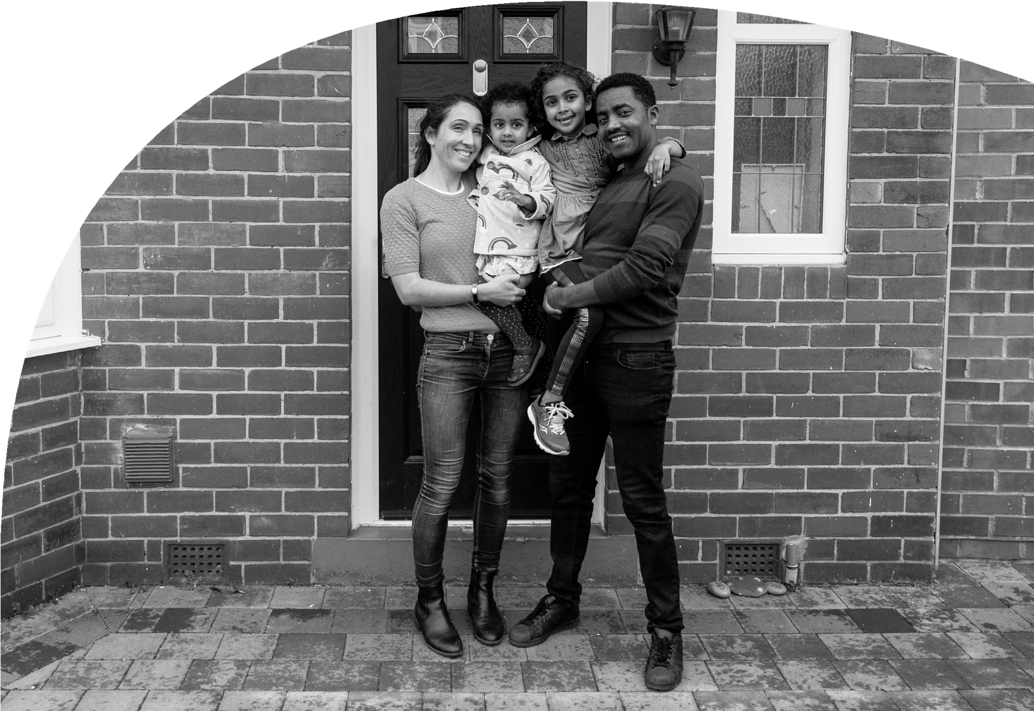

31
26
5
0

Recommendations for energy and water suppliers

Prioritise disabled customers who are already in debt

More than 4 in 10 (43%) callers to Scope’s energy helpline were already in energy debt this summer, on average to the tune of £1,351. Our polling has also found that 24% of disabled adults are currently in debt with their energy supplier, with an average debt of £254.

Energy suppliers must urgently reach out to households with disabled people in them if they are in debt, to offer help and support. Without this proactive approach, the debt disabled customers are in will only increase causing further hardship.

Proactive action from energy and water suppliers when a disabled customer first enters debt, or is at risk of doing, also benefits the supplier. Providing assistance early can lessen the risk of bad debt to the supplier that ultimately ends up getting written off.

Provide effective, empathetic support that for disabled customers

Disabled customers that have received support from their energy supplier are split around the effectiveness of the support, with 48% deeming it as effective and 47% feeling it was not effective. Disabled people have told us that energy savings advice, fuel vouchers and grants are the most useful forms of support.

Of those who have been contacted by their supplier, 37% felt stressed, and 36% felt anxious by their interaction with their energy supplier, with 34% feeling upset or scared.

Energy and water suppliers should make a commitment to be disability aware and fully equipped to support disabled people, whether this is on the phone, digitally or even through the written communications they send.

Scope would like to see a consistent approach across the energy and water sectors to ensure disabled customers are treated the same regardless of which supplier they are with.

We know that some suppliers, in particular those in the Scope Utility Membership, are especially proud of the work they do in this area. Scope would be pleased to collaborate with suppliers to roll out co-produced training programmes to benefit disabled people.

Increase awareness of ‘Water Sure’

‘Water Sure’ is a water utilities tariff offered by all water companies to customers where someone in the household has a medical condition that means they have to use more water and are in receipt of certain benefits. However, only 33% of households with a disabled person present are aware of this scheme. Water companies should therefore contact their disabled customers to raise awareness of the scheme and sign-up qualifying customers.

Increase awareness of the Priority Services Register (PSR)

The PSR, whilst limited in its effectiveness in dealing with costs, is still a vital tool that all disabled customers and households should be signed up to. This is particularly important in the case of power or water outages.

Energy suppliers, networks, and water companies all have an important role to play in ensuring all qualifying customers are aware of the PSR and signed up to it. Companies should reach out to all their customers, especially new customers, or customers they haven’t contacted before, by phone or post, as well as promoting on social media. Furthermore, it is vital that a disabled customer on the PSR gets the full benefits of being registered related to their requirements.

Establish two-way signposting with a dedicated number for charities

Energy and water suppliers should build partnerships with disability charities, disabled people’s organisations and others who can provide specialist support. Given the pressure suppliers are under, they cannot be expected to provide all the types of support needed, such as income maximisation and debt advice. More trusted, specialised charities and organisations can step in here. However, this should be a two-way process, and energy and water suppliers should provide charities working in this space with a dedicated hotline.

The final word from Susanne

My name is Susanne Crosby. My daughter Mia is a wonderful, engaging and sociable young woman. Mia also has profound and multiple disabilities. Mia is curious and generous, caring and happy, yet dependent on others around her for absolutely everything. She has very little control over her own life and bears this with a grace and dignity that astonishes me and fills me with admiration.

Mia has ten pieces of electrical “kit” which need constant charging, plus other things that need to be kept in the fridge. With hoists, slings, and changing pads, washing needs to be done every single day, sometimes a hot disinfectant wash which means doing a load twice.

We don’t have a choice over electricity and water usage; these are the bare necessities that it takes for us to live, and that’s without heating costs and cooking meals. Mia needs two or three cooked meals a day otherwise her weight drops; and she can’t control her body temperature plus being in a wheelchair means we have to
have heating for her.

Some of our bills have doubled, others tripled. We have considered moving house, but we can’t afford anywhere within the area so that Mia can still get the same services she does now. We are completely bound here. My partner’s salary doesn’t go up and my Carer’s Allowance equates to approximately 59 pence per hour.

We don’t have any time we can magic up to get another job to bring in more money. All we see going forward is the never-ending increase in costs of energy, water and food.

We didn’t choose this life. We were senior managers in local government earning a fair salary. We had to give it all up because these are the cards we were dealt.

We’re struggling and I can’t be there for Mia unless I’m looking
after myself. But it’s increasingly difficult to prioritise this when you are so stressed about being able to afford the bare necessities.

How do we know it’s going to get better? It certainly doesn’t feel like it at the minute. We keep getting squeezed and squeezed. Sometimes I just have yoghurt for lunch because food is the onlyplace we can make cuts.

Those in power need to act and this Scope report sets out what must be done. For me, in the short term, support packages and subsidies to those who need it would really help. In the long term, energy, and other companies, need to consider more ways to help customers who need it. Government must do more but I feel it is just washing its hands of anyone even potentially vulnerable, hoping that they just go away.

Susanne Crosby
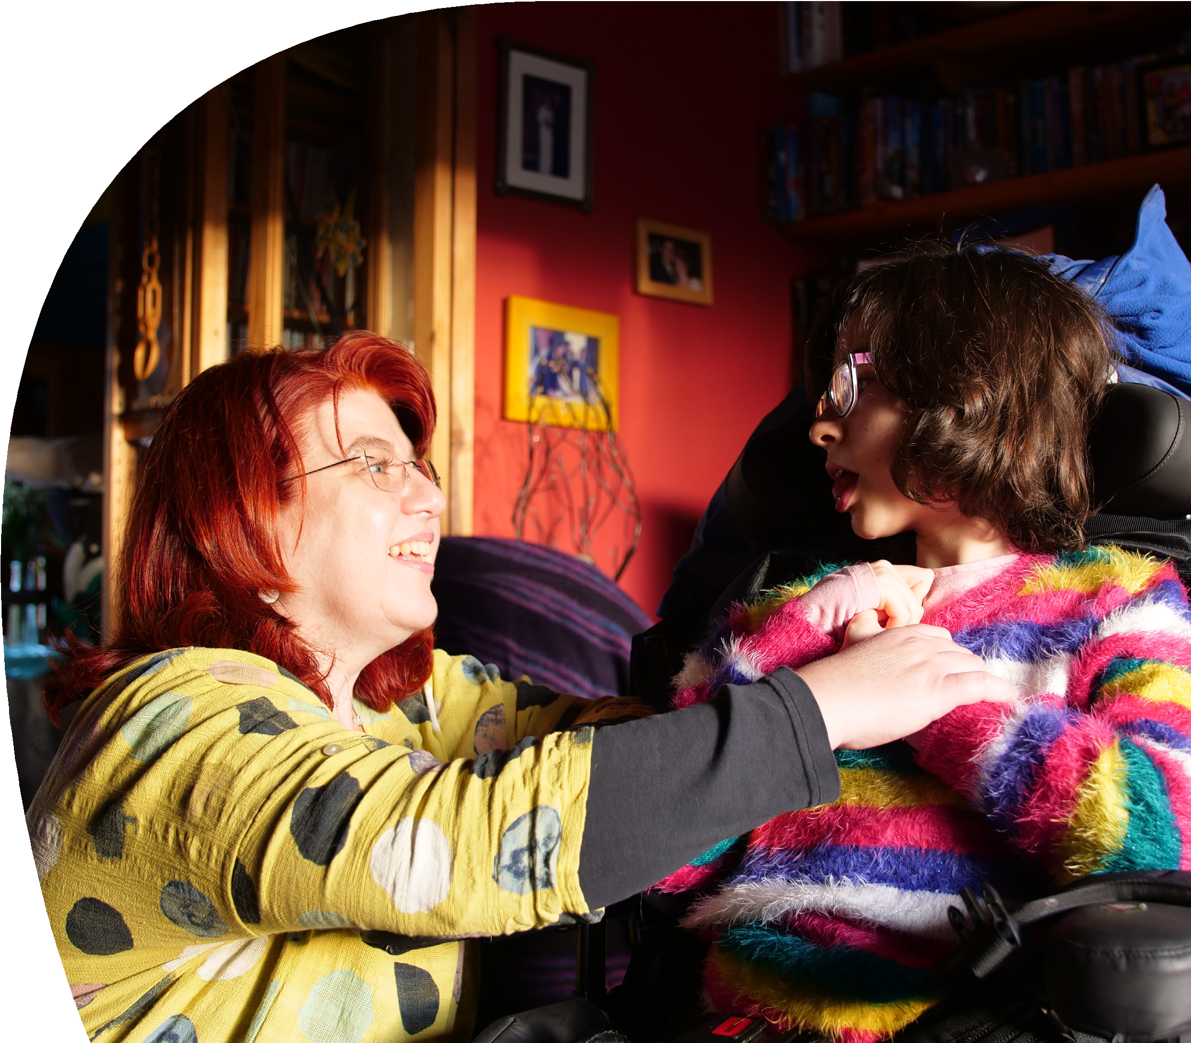

WE CAN’T TURN OFF OUR

NEBULISERS OR DIALYSIS MACHINES

YOU CAN DO THE RIGHT THING FOR DISABLED PEOPLE

This report has been compiled to give you a picture of what life is like for disabled people in Britain right now. In it you’ll see how choices over energy, food, care costs and other vital aspects of living have been stripped away by current circumstances.

You’ll also see multiple ways you can help give those choices back, to lift the fear and uncertainty that this crisis has brought into so many lives.

We can’t make these changes. You can. Working together we can do the right thing for disabled people.

SC0903 Scope is a registered charity, number 208231 and is a company limted by guarantee number 520866 (England).
Registered office: Here East Press Cenre, 14 East Bay Lane, London E15 2GW Copyright Scope November 2022.

Scope (2019), Disability Price Tag – Policy report, https://www.scope.org.uk/campaigns/extra-costs/disability-price-tag/
From April to October 2022 a single disabled adult over the age of 25 on income-based Employment and Support Allowance (ESA) and associated premiums has already seen a cut of £381 on average and up to £687 in real terms. This takes into account the real terms cuts to benefits seen when these benefits were uprated in April 2022 as well as the continued rise in inflation from April 2022 to October 2022. These figures are rounded to the nearest pound.
Social Market Foundation and Scope (2021), Time to Think Again – Policy report, https://www.scope.org.uk/campaigns/research-policy/disability-benefits-and-support-after-coronavirus/
From April to October 2022 a single disabled adult over the age of 25 on income-based Employment and Support Allowance (ESA) and associated premiums has already seen a cut of £381 on average and up to £687 in real terms. This takes into account the real terms cuts to benefits seen when these benefits were uprated in April 2022 as well as the continued rise in inflation from April 2022 to October 2022. These figures are rounded to the nearest pound.
Resolution Foundation (October 2022), The Long Squeeze – Policy report, https://www.resolutionfoundation.org/app/uploads/2022/10/The-Long-Squeeze.pdf
These figures account for the real terms cuts to benefits seen when those benefits where uprated in April 2022. They do not account for any further depreciation of the real terms value of benefits as a result of the continued rise in inflation from April 2022 to the present day. These figures are rounded to the nearest pound, depending on benefit award
Actual number is 6,830,229. The UK government does not publish the number of people with a disability that receive Universal Credit. A proxy for this is the number of people on income replacement benefits who do not have any work requirements placed on them. While this figure will include some non-disabled people (e.g. lone parents with very young children), however overall it is likely to be an underestimate, as many disabled people have found themselves in conditionality groups where they are required to prepare for work. The other numbers that make up this figure are the number of people currently in receipt of PIP, income and contribution based ESA, Incapacity Benefit and Severe Disability Allowance and DLA, including children and people over the state pension age on DLA.
Resolution Foundation, The Long Squeeze
Warm Home Discount: Eligibility Statement (England and Wales) (November 2022), https://www.gov.uk/government/publications/warm-home-discount-eligibility-statement-england-and-wales
From April to October 2022 a single disabled adult over the age of 25 on income-based Employment and Support Allowance (ESA) and associated premiums has already seen a cut of £381 on average and up to £687 in real terms. This takes into account the real terms cuts to benefits seen when these benefits were uprated in April 2022 as well as the continued rise in inflation from April 2022 to October 2022. These figures are rounded to the nearest pound.
Actual number is 6,830,229. The UK government does not publish the number of people with a disability that receive Universal Credit. A proxy for this is the number of people on income replacement benefits who do not have any work requirements placed on them. While this figure will include some non-disabled people (for example lone parents with very young children), however overall it is likely to be an underestimate, as many disabled people have found themselves in conditionality groups where they are required to prepare for work. The other numbers that make up this figure are the number of people currently in receipt of PIP, income and contribution based ESA, Incapacity Benefit and Severe Disability Allowance and DLA, including children and people over the state pension age on DLA.
Further information on NHS service specifications is available at https://www.england.nhs.uk/specialised-commissioning-document-library/service-specifications/
Contact (2022) Out of Energy. Available at https://contact.org.uk/help-for-families/campaigns-and-research/out-of-energy/
F or further information on the Child Winter Heating Assistance is available at https://contact.org.uk/help-forfamilies/information-advice-services/benefits-financial-help/welfare-benefits-in-scotland/child-winterheating-assistance/
BBC News (February 2022), “Prepayment energy customers feeling the strain”, https://www.bbc.co.uk/news/business-60291912

